Experiment 3

Write a program for a HLDC frame to perform character stuffing and de-stuffing in a single frame

Program:

#include<stdio.h>

#include<string.h>

#include<conio.h>

#define DLE 16

#define STX 2

#define ETX 3

void main() {

char ch,arr[50]={DLE,STX},rec[50];

int len=2,i,j;

printf("Enter the data stream: Ctrl+P -> DLE Ctrl+B -> STX Ctrl+C -> ETX \n");

while((ch=getch())!='\r') {

if(ch==DLE) {

arr[len++]=DLE;

printf("DLE");}

else if(ch==STX)

printf("STX");

else if(ch==ETX)

printf("ETX");

else

printf("%c",ch);

arr[len++]=ch;}

arr[len++]=DLE;

arr[len++]=ETX;

printf("\nThe stuffed stream is:\n");

for(i=0;i<len;i++) {

ch=arr[i];

if(ch==DLE)

printf("DLE");

else if(ch==STX)

printf("STX");

else if(ch==ETX)

printf("ETX");

else

printf("%c",ch);}

printf("\nThe destuffed stream is:\n");

for(j=2;j<len-2;j++) {

ch=arr[j];

if(ch==DLE) {

printf("DLE");

j++;}

else if(ch==STX)

printf("STX");

else if(ch==ETX)

printf("ETX");

else

printf("%c",ch);}

getch();

}

Output:

(With “welcome” as data stream)

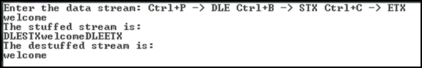

(With “DLEhelloSTXhiETX” as data stream)

